Meet the Sta 101 TA’s + Our Office Hour Tips

## Joe mathews joseph.mathews@duke.edu Head TA

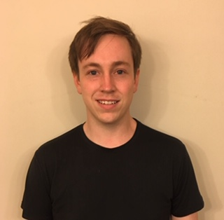Hi, my name’s Joe and I’m a PhD student in the statistical sciences department! I’m originally from Clarksville, TN and I like dogs and playing music.

Students should try to ask precise questions in office hours so that we can answer their questions efficiently. They should expect TAs to guide them towards the correct solution.

## Joseph Ekepenyong joseph.ekpenyong@duke.edu

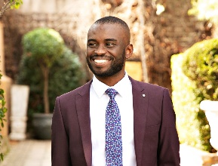 Hello, I am Joseph, a Master’s student in Statistical Science, and I am from Nigeria. I received my Bachelor’s degree in Mathematics from Bates College, ME and I most recently taught mathematics at a boarding school in South Africa. Outside of academics, I love watching and analyzing sports, dancing, and cycling.

I hope you will build a rhythm of using office hours early in the term whether for clarifying minor concepts or understanding large topics. It could be beneficial to master introductory concepts as they are repeated many times later in the course.

## SIMONE NABORS simone.nabors@duke.edu

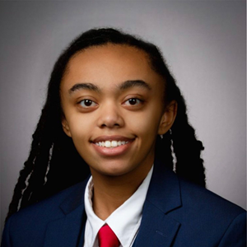Hello, my name is Simone (she/they), and I am a sophomore from Wake Forest, NC majoring in Neuroscience with minors in Chemistry and Photography all on the pre-med track. I am particularly interested in improving access to healthcare, specifically for the LGBTQ+ community, as well as storytelling. In my free time I love to travel, read, and learn about new things, whether that be how to solve some sort of puzzle or a random fact that I will likely never need to know.

My biggest piece of advice regarding office hours is to use them! If you’ve been stuck on a concept/question and have already done your best to find the solution based on the text and lecture materials, don’t hesitate to come to office hours to ask for help. In general, it is best to come with specific questions, and we can work from there.

## BEN WALLACE BEN.WALLACE@duke.edu

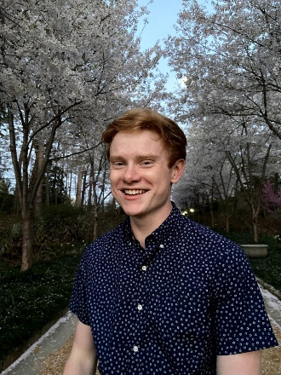 My name is Ben and I'm a junior studying "Constructions of Race and Racial Attitudes in the United States" through Program II! I'm originally from Apex, North Carolina, and I've enjoyed spending the past few years exploring new music, art, and food here in Durham.

## AEVA Jazic AEVA.jazic@duke.edu

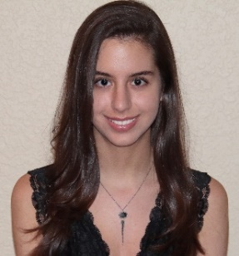 Hi, I’m Aeva. I’m a senior majoring in Biology with a concentration in Cell and Molecular Biology and a minor in Chemistry. I’m originally from Parkland, Florida but moved to Durham two years ago. For fun, I love cooking, hiking, and playing with my dogs.

## Ginny Hagerty virginia.hagerty@duke.edu

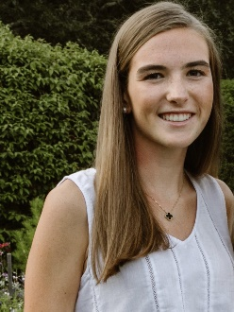 My name is Ginny Hagerty and I am a junior from New Jersey. I am studying Public Policy with an MMS certificate. In my free time, I love reading, running, and trying new restaurants in Durham (any recommendations are welcome!). My advice for office hours is to come prepared with specific questions and then ask follow up questions to make sure you understand the material. Definitely use office hours as a resource—we are all here to help!

## Gaurav Sirdeshmukh gaurav.Sirdeshmukh@duke.edu

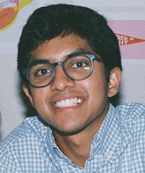 Hi everyone, my name is Gaurav (Gow-ruv) and I'm a junior from Chapel Hill, NC. I'm a statistics major and on the pre-med track. In my free time I love to perform and listen to music, watch sports, and occasionally experiment in the kitchen.

Coming with questions prepared will help make office hours as efficient as they can be - I look forward to meeting many of you there!

Compiled by Jacob Smith; originally Head TA Emily Gentles’ idea for Fall 2020